_EDUCATION AUTHORITY - NORTH EASTERN REGION____________________
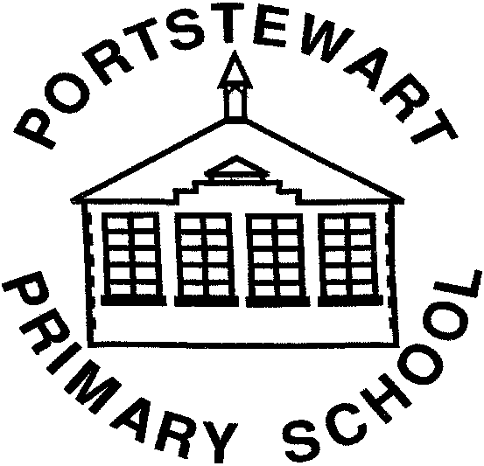 | PORTSTEWART PRIMARY SCHOOL  and NURSERY UNIT  Principal: Mrs K. Taylor, B.Ed, PQH (NI)  Telephone: (028) 7083 2194 | 22-24 Central Avenue  Portstewart  Co. Londonderry  BT55 7BT

Class of 2020 Leavers’ DVD
Dear Parent,
As I return to school it is my intention to work with Mrs Baillie, Mrs Bradley, primary seven children and their parents to help create a “Class of 2020” Leavers’ DVD.

This would involve parental support and participation through helping to record short videos and providing photographs etc which we could then use to edit and create a DVD for the children. I would hope that this would go, in some small way, to help with the disappointment of missing their usual Leavers’ Event.

As you will recognise, this project will take some time, so it would help greatly if you participate in the project as part of the ‘Home Schooling’ schedule. We feel that this would better reflect their final term in the primary seven classroom.

Examples of items are listed below but we have also created a FRONTER Room for the children to contribute. This can be accessed by logging on to MYSCHOOL and clicking on the Fronter App. If your child has forgotten their password, please email and we can reset it. You will find more details and the opportunity to respond with your views and ideas using the VOTE and FORUMs

We would appreciate it if you would complete the table below, or the online version, as soon as possible, indicating how you could help and in what capacity your child would like to participate for the DVD.

Any other suggestions that you might have would be greatly welcomed.

Child’s Name: __________________________________________________

We can help provide the following material for the “Class of 2020” Leavers’ DVD:
1 | Video about:
2 | Video of my child performing:
3 | Sign Language:  Song:  Poem:
4 | Provide any photographs from events in schools etc for the slideshow: Our Journey Through PPS.
5 | Supply Photographs for Slideshow from Nursery/P1: Should be in a school uniform or Nursery Nativity, if possible.
6 | Provide a recent photograph of your child
7 | Help with editing DVD

